ICT Safety_E-Safety
Overall task – To look at the dangers when using ICT
Bronze 1

Task 1

When working with electronic equipment you will need to make sure there are no hazards. (Hint – Look at the Literacy document at the end to find out what hazard means)

Find and fill in the text boxes on the Hazards in the picture below:
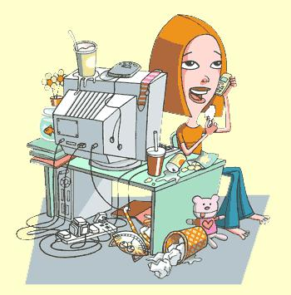
Hazard 1:
Her drink is spilling on the computer it could give her electric shock

Hazard 2: the goldfish bowl is next to the computer

Hazard 5:
The juice could spill over.
Hazard 3:
The wires aren’t put tidily.

Hazard 6:
The drink has spilt
Hazard 4:
The can could get electrocuted

Task 2
How to sit at a Computer
Fill in the Blanks
Bad Posture

You will have ____________ if you do not adjust your chair so that your lower back is properly supported. A correctly ____________chair will not put strain on your back. Adjust your chair height so that you can use the keyboard with your wrists and forearms straight and level with the floor. This will not allow you to have_______________________.
Repetitive strain injury
Flat
Adjusted
Your feet should be_______ on the floor. If they’re not, ask if you can have a footrest, which lets you rest your feet at a level that’s comfortable. Don't cross your legs, as this can cut off_______________and cause hip problems. Your screen should be directly in front of you. A good guide is to place the____________ about an arm's length away, with the top of the screen roughly at eye level.
Straight

Monitor
Circulation
Your wrists should be _________ when using a keyboard. Position and use the mouse as close to you as possible. A mouse mat with a wrist pad may help to keep your wrist straight and stop___________.
Glare-free

Back Pain
Your screen should be as__________as possible. If there’s glare on your screen, hold a mirror in front of it to identify the cause. Position the monitor to avoid ____________from overhead lighting and sunlight. Position frequently used objects, such as your telephone or stapler, within easy reach. Stop repeatedly _____________or twisting to reach things.
Stretching
Reflection

Bronze 3.1

Task 3

Copy and paste the following sentences next to the correct picture in the table. There will be only one sentence per picture and ALL sentences must be used.
The first one is done for you

Picture | Sentence
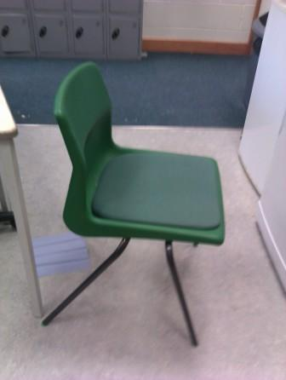 | Unsafe use of ICT – A chair that can’t be adjusted for height and position
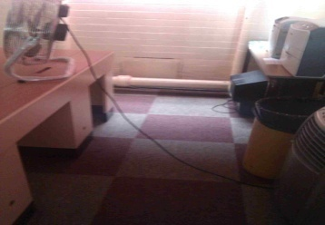 | Unsafe use of ICT - A wire in the middle of a walking area that somebody can trip over
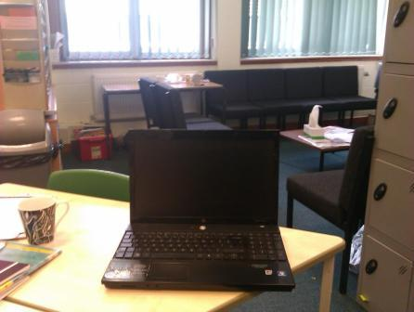 | Safe use of ICT – Open space behind the screen to look at when you take a rest.
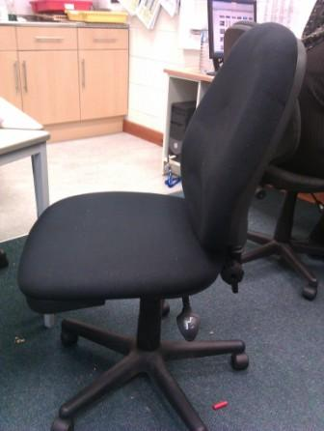 | Safe use of ICT – An adjustable chair so that your back wont get hurt as you can adjust it for height and position
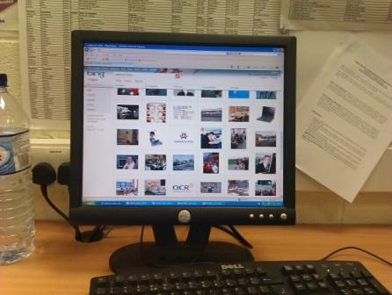 | Unsafe use of ICT – A wall directly in front of you for when you take a rest
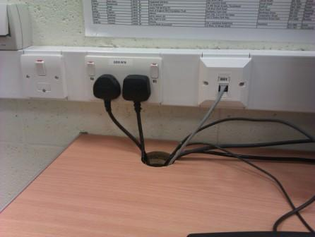 | Safe use of ICT – All wires are nice and tidily together in one place.
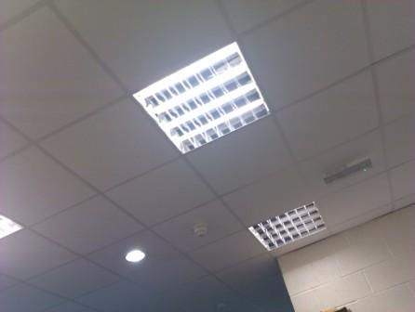 | Safe use of ICT - Good light in the room
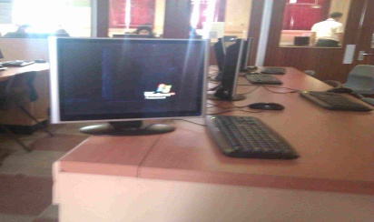 | Unsafe use of ICT – A monitor that could fall off the desk easily because it hasn’t been positioned correctly
 | Unsafe use of ICT - Lights off or dim in the room

Task 4
To succeed in this task your teacher must have seen you work collaboratively and safely in an ICT suite.
Remind your teacher of how you work collaboratively by filling in the table below. One example is there for you. You must give 3 of your own.
What I did | When? | Who was you collaborating with? | How could you improve this way of collaborating?
Example:-I listen to others and gave ideas when working in a group | During the spreadsheet project in April 2011 | Adil, Zackaria, Sumaya and Nadia | I could give more time for others to give their ideas.
I helped her with her work when she was stuck | On the computer software assessment. | Atiyah

Remind your teacher of how you work safely by filling in the table below. One example is there for you. You must give 3 of your own.
What I did | When? | Why? | What could happen if you didn’t do it?
Example:-I tuck my chair under the desk when I leave the room and my computer | Every time I leave my computer | So that nobody trips up over the chair | Someone could trip up and split their head open.
No drinking or eating near the computer | During lesson time. | So nobody gets electrocuted | Someone could get electrocuted
Keep mouse and keyboard tucked in | Every time i leave the classroom | To keep it tidy | The wires can hurt someone

Task 5
Visit this website which shows what risks there are when you go online.
Fill in the table below, the first example is done for you. You have 3 more to do.

Activity | What’s wrong with it | What bad things might happen
Speaking to a stranger on face book | You don’t know who the person in | You might get persuaded to meet up with them and s/he might kidnap you.

Bronze 3.2

Task 6

Chatrooms are used inappropriately in today’s society, looking at the picture below write what you think could be the consequences of chatrooms:

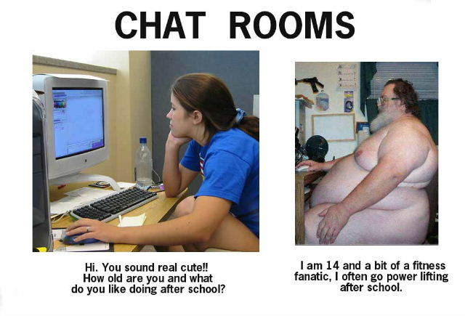
What are the dangers of chatrooms? Create a bullet list.
- You don’t know who you’re talking to.
- It could be somebody dangerous
- They can kill you
- Or kidnap you.
- They can stalk you.

Task 7

– Text Bullying
Fill in if you agree or disagree by typing ‘YES’
 | Agree | Disagree
1. We could all live without text messaging | yes
2. Text bullying is just like any other type of bullying – just normal behaviour and not really a problem |  | yes
3. Is it down to schools to deal with text bullying? |  | yes
4. It takes more courage to stand up against bullying than to join in | yes
5. Someone who encourages a bully is as bad as the bully themselves | yes
6. People who text bully should be banned from having a phone |  | yes

