Silver Unit 15 Imaging software _1.5– Planning Document
You will be creating a poster that advertises any made up product.
Your poster will contain 3 images and some text and/or tables.
It must be saved as a .jpg file ready to be emailed to people.

Complete this planning document before you complete the task.

Question/Task | Answer
What will the product be that you are advertising? | Glow in the dark phone case
What is the purpose of the poster? | To promote and advertise the product. Also to make the audience aware of my product.
Who is the target audience? | Teenagers 13+
What software will you be using to edit the images?  Is it open source/proprietary?  Why will you be using it?  How much does it cost?  Why is it suitable for you to use at home aswell? | I will be using inkscape to produce my logo and pictures.
What other piece of software could you have used?  Is it open source/proprietary?  How much does it cost?  Why is it suitable for you to use at home aswell? | Firework
Image 1 will be a vector graphic and is to be saved as a .svg. What designs/styles in this logo will make it suitable for the audience you have chosen. | It will be colourful and eye catching so it attracts the audience.
Roughly draw image 1 on paper, take a photo of it and insert it into the box on the right. | 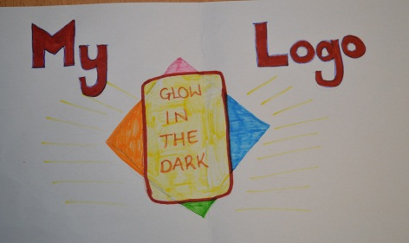
Image 2 will be a bitmap/raster image. It must be saved as a .jpg file. Describe what design points of the image will ensure it suits the audience and purpose. | Colourful, stylish and eye catching.
Roughly draw image 2 on paper, take a photo of it and insert it into the box on the right. | 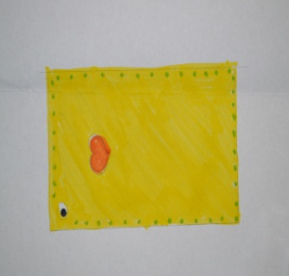
Image 3 will also be a bitmap/raster image. It must be saved as a .png file. It needs at least 2 separate images in the image. i.e a dog being happy eating his food in one image and sad eating some other food. These 2 images will then be combined into one. Describe what design points of the image will ensure that it suits the audience and purpose.
Roughly draw image 3 on paper, take a photo of it and insert it into the box on the right.
Roughly draw the whole poster, with the 3 images included and include some separate text somewhere in the poster. Take a photo and insert. | 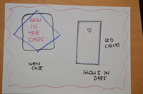

Feedback on plan
Plan
Feedback 1
Does my plan need any amendments and do the planned images suit my audience and why?
My plan does not need any amendments and it is suitable for my target audience.
Feedback 2
Have the changes you asked for in feedback 1 improved my plan, how?
Feedback 3
Does the final product drawing in my plan suit the original purpose(advertising)?
My plan does suit the purpose and it is suitable for advertising.

